1. registration page

<?php if(isset($_POST['submit']))

{

$email=$_POST['email'];

$password=$_POST['password'];

$mobile=$_POST['mobile'];

$conn=mysqli_connect("localhost","root","","test"); if($conn){

echo "database connection established";

$checkquery="SELECT * FROM `users` WHERE email='$email' and password='$password'";

$result=mysqli_query($conn,$checkquery);

$count=mysqli_num_rows($result); if($count==1)

{

echo "user already registered.please login !";

}

else{

$query="INSERT INTO `users`(`email`, `password`, `mobile`) VALUES ('$email','$password','$mobile')";

$result1=mysqli_query($conn,$query); if($result1){

echo "registration succesfull";

}

else{

}

}

}

else{

}

}

?>

echo "registration unsuccessful";

echo "db conn not established";

<html>

<body>

<form action="" method="POST">

<input type="email" placeholder="Enter email" name="email" required><br>

<input type="password" placeholder="enter password" name="password"

required><br>

required><br>

<input type="tel" name="mobile" placeholder="enter mobile number"

<input type="submit" name="submit">

</form>

</body>

</html>

**Login Page**

<?php if(isset($_POST['submit']))

{

$email=$_POST['email'];

$password=$_POST['password'];

$conn=mysqli_connect("localhost","root","","test"); if($conn){

echo "database connection established";

$checkquery="SELECT * FROM `users` WHERE email='$email' and password='$password'";

$result=mysqli_query($conn,$checkquery);

$count=mysqli_num_rows($result); if($count==1)

{

}

else{

}

}

else{

}

}

?>

echo "Login succesful";

echo "login unsuccess";

echo "db conn not established";

<html>

<body>

<form action="" method="POST">

<input type="email" placeholder="Enter email" name="email" required><br>

<input type="password" placeholder="enter password" name="password"

required><br>

<input type="submit" name="submit">

</form>

</body>

</html>

1. Create a PHP program to add 2 numbers, which were received from a HTML page and display the result back onto the html page.

<?php if(isset($_POST['submit']))

{

$num1=$_POST['num1'];

$num2=$_POST['num2'];

echo "Addition of two numbers is : ".($num1+$num2);

}

?>

<html>

<body>

<form action="" method="POST">

<input type="number" name="num1" value="<?php if($num1) echo $num1 ?>" required>

<input type="number" name="num2" value="<?php if($num2) echo $num2 ?>" required>

<input type="submit" name="submit">

</form>

</body>

</html>

1. Design a dynamic web page with validation using JavaScript.

<!DOCTYPE html>

<html>

<head>

<title>form</title>

</head>

<body>

<form action="#" method="POST" onsubmit="return fun()" style="text-align: center;" action="action.php">

Name:<input type="text" name="name" id="name" required>

<div style="font-size: 15px; color: red;" id="n1"></div>

<br>

UserName:<input type="text" name="uname" id="uname" required>

<div style="font-size: 15px; color: red;" id="n2"></div>

<br>

Password:<input type="password" name="pwd" id="pwd" required>

<div style="font-size: 15px; color: red;" id="n3"></div>

<br>

Email:<input type="text" name="email" id="email" required>

<div style="font-size: 15px; color: red;" id="n4"></div>

<br>

Place:<input type="text" name="place" id='place' required>

<br>

<input type="submit" value="submit" > &nbsp;&nbsp;

<input type="reset" name="reset" >

</form>

<script type="text/javascript"> function fun()

{

document.getElementById("n1").innerHTML="" document.getElementById("n2").innerHTML="" document.getElementById("n3").innerHTML="" document.getElementById("n4").innerHTML=""

var name =document.getElementById('name').value; var uname=document.getElementById('uname').value; var pwd=document.getElementById('pwd').value;

var email=document.getElementById('email').value; var ru=/^[a-zA-Z0-9]+$/;

var rp=/^(?=.*\d)(?=.*[a-z])(?=.*[A-Z])(?=.*[^a-zA-Z0-9])(?!.*\s).{8,}$/; var words = name.split(" ");

var rem=/^^[a-zA-Z][-_.a-zA-Z0-9]{5,29}@gmail.com$/;

for (let i = 0; i < words.length; i++) {

words[i] = words[i][0].toUpperCase() + words[i].substr(1);

}

var k=words.join(" ");

if (name!=k) {

document.getElementById("n1").innerHTML="The first Letter of every word in the name should be Capital.";

return false;

}

else if(uname.length!=10){ document.getElementById("n2").innerHTML="The Username can

be anything with letters and numbers.(Must be of length 10 characters)"; return false;

}

else if(!uname.match(ru)){ document.getElementById("n2").innerHTML="The Username can

be anything with letters and numbers.(Must be of length 10 characters)"; return false;

}

else if(!pwd.match(rp)){

document.getElementById("n3").innerHTML="The password must contain a capital letter, a small letter, a number and a special character. It should be minimum of 8 characters and maximum of characters.";

return false;

}

else if(!email.match(rem)){ document.getElementById("n4").innerHTML="Email should

contain '@gmail.com' in the end";

return false;

}

var nm1=uname.slice(0,3); var nm2=uname.slice(-3); alert(nm1+nm2);

return true;

}

</script>

</body>

</html>

1. Create a servlet program to add 2 numbers, which were received from a HTML page and display the result back onto the html page

Add.html

<html>

<body>

<form action="add">

Enter 1st number :<input type="text" name="num1"><br> enter 2nd number:<input type="text" name="num2"><br>

<input type="submit">

</form>

</body>

</html>

AdditionServlet.java

import javax.servlet.http.HttpServlet;

import javax.servlet.http.HttpServletRequest; import javax.servlet.http.HttpServletResponse;

import java.io.IOException; import java.io.PrintWriter;

public class AdditionServlet extends HttpServlet

{

IOException

public void service(HttpServletRequest req, HttpServletResponse res) throws

{

int i=Integer.parseInt(req.getParameter("num1")); int j=Integer.parseInt(req.getParameter("num2"));

int k=i+j;

//PrintWriter obj=new PrintWriter(); PrintWriter out=res.getWriter(); out.println("resultis"+k);

//System.out.println(k);

}

}

web.xml

<?xml version="1.0" encoding="UTF-8"?>

<web-app xmlns:xsi="<http://www.w3.org/2001/XMLSchema-instance>" xmlns="<http://xmlns.jcp.org/xml/ns/javaee>" xsi:schemaLocation="<http://xmlns.jcp.org/xml/ns/javaee> <http://xmlns.jcp.org/xml/ns/javaee/web-app_3_1.xsd>" id="WebApp_ID" version="3.1">

<display-name>add</display-name>

<welcome-file-list>

<welcome-file>index.html</welcome-file>

<welcome-file>index.htm</welcome-file>

<welcome-file>index.jsp</welcome-file>

<welcome-file>default.html</welcome-file>

<welcome-file>default.htm</welcome-file>

<welcome-file>default.jsp</welcome-file>

</welcome-file-list>

<servlet>

<servlet-name>abc</servlet-name>

<servlet-class>AdditionServlet </servlet-class>

</servlet>

<servlet-mapping>

<servlet-name>abc</servlet-name>

<url-pattern>/add</url-pattern>

</servlet-mapping>

</web-app>

1. Create two Servlet programs, one to calculate total of 3 subject marks, received from the html page and other servlet to find the percentage of marks received from 1st servlet and display the result on to HTML page.

<!DOCTYPE html>

<html>

<head>

<meta charset="ISO-8859-1">

<title>Insert title here</title>

</head>

<body>

<form action="servlet1" method="post">

Enter 1st subject marks :<input type="text" name="num1"><br>

enter 2nd subject marks:<input type="text" name="num2"><br> enter 3rd subject marks:<input type="text" name="num3"><br>

<input type="submit" value="calculate">

</form>

</body>

</html>

import java.io.IOException; import java.io.PrintWriter;

import javax.servlet.RequestDispatcher; import javax.servlet.ServletException; import javax.servlet.annotation.WebServlet; import javax.servlet.http.HttpServlet;

import javax.servlet.http.HttpServletRequest; import javax.servlet.http.HttpServletResponse;

public class TotalServlet extends HttpServlet {

protected void doPost(HttpServletRequest request, HttpServletResponse response) throws ServletException, IOException {

response.setContentType("text/html"); PrintWriter out = response.getWriter();

int m1=Integer.parseInt(request.getParameter("num1")); int m2=Integer.parseInt(request.getParameter("num2")); int m3=Integer.parseInt(request.getParameter("num3")); int total=m1+m2+m3;

String s=String.valueOf(total); request.setAttribute("total",s);

RequestDispatcher rd=request.getRequestDispatcher("servlet2"); rd.forward(request, response);

}

}

import java.io.IOException; import java.io.PrintWriter;

import javax.servlet.ServletException; import javax.servlet.annotation.WebServlet; import javax.servlet.http.HttpServlet;

import javax.servlet.http.HttpServletRequest; import javax.servlet.http.HttpServletResponse;

public class AverageServlet extends HttpServlet {

protected void doPost(HttpServletRequest request, HttpServletResponse response) throws ServletException, IOException {

response.setContentType("text/html"); PrintWriter out = response.getWriter();

String s=(String) request.getAttribute("total"); int total=Integer.parseInt(s);

int avg=total/3; out.print("total "+total); out.print("average "+avg);

}

}

<?xml version="1.0" encoding="UTF-8"?>

<web-app xmlns:xsi="<http://www.w3.org/2001/XMLSchema-instance>" xmlns="<http://xmlns.jcp.org/xml/ns/javaee>" xsi:schemaLocation="<http://xmlns.jcp.org/xml/ns/javaee> <http://xmlns.jcp.org/xml/ns/javaee/web-app_3_1.xsd>" id="WebApp_ID" version="3.1">

<display-name>marks</display-name>

<welcome-file-list>

<welcome-file>index.html</welcome-file>

<welcome-file>index.htm</welcome-file>

<welcome-file>index.jsp</welcome-file>

<welcome-file>default.html</welcome-file>

<welcome-file>default.htm</welcome-file>

<welcome-file>default.jsp</welcome-file>

</welcome-file-list>

<servlet>

<servlet-name>servlet1</servlet-name>

<servlet-class>TotalServlet</servlet-class>

</servlet>

<servlet>

<servlet-name>servlet2</servlet-name>

<servlet-class>AverageServlet</servlet-class>

</servlet>

<servlet-mapping>

<servlet-name>servlet1</servlet-name>

<url-pattern>/servlet1</url-pattern>

</servlet-mapping>

<servlet-mapping>

<servlet-name>servlet2</servlet-name>

<url-pattern>/servlet2</url-pattern>

</servlet-mapping>

</web-app>

1. Differentiate GET and POST methods using a PHP code.

<?php if(isset($_POST['postm'])){

$num1=$_POST['num1'];

$num2=$_POST['num2'];

echo "data obtained in the post array and data also not visible in url"."<br>"; echo "data received is :".$num1." and ".$num2;

}

if(isset($_GET['getm'])){

$num1=$_GET['num1'];

$num2=$_GET['num2'];

echo "data obtained in the get method and data also visible in url and one can change the values in url"."<br>";

echo "data received is :".$num1." and ".$num2;

}

?>

<html>

<body>

<h2>POST method example</h2>

<form action="" method="POST">

<input type="number" name="num1"><br>

<input type="number" name="num2"><br>

<input type="submit" name="postm">

</form>

<br>

<br>

<h2>GET method example</h2>

<form action="" method="GET">

<input type="number" name="num1"><br>

<input type="number" name="num2"><br>

<input type="submit" name="getm">

</form>

</body>

</html>

1. Differentiate between Service, GET and POST methods in Servlets with code <https://www.knowprogram.com/servlet/doget-dopost-in-servlet-example/> <https://www.tutorialspoint.com/servlets/servlets-form-data.htm>
2. Design a web page consisting of a) Home page b) Login page c) Catalogue page
3. Create a table which should contain at least the following fields: name, password, emailid, phone number (these should hold the data from the registration form).
4. Write a PHP program to connect to that database and extract data from the tables and display them.

<!DOCTYPE html>

<html>

<head>

<meta charset="utf-8">

<title>registration form</title>

</head>

<body>

<?php if(isset($_POST['register'])){

$name=$_POST['name'];

$password=$_POST['password'];

$email=$_POST['email'];

$mobile=$_POST['number'];

$conn=mysqli_connect("localhost","root","","test"); if($conn){

$query="INSERT INTO `reg` (`name`,`password`,`email`,`mobile`) VALUES ('$name','$password','$email','$mobile')";

$res=mysqli_query($conn,$query); if($res){

echo $name."Registered successfully";

}

else{

echo "registration failed";

}

}

else{

echo "Failed to connect database";

}

}

?>

<form action="" method="POST"> name:

<input type="text" name="name" placeholder="name">

<br> password:

<input type="password" name="password" placeholder="password">

<br> email:

<input type="email" name="email" placeholder="email">

<br> number:

<input type="text" name="number" placeholder="number">

<br>

<input type="submit" name="register" value="register">

</form>

</body>

</html>

1. Insert the details of the users who register with the web site, whenever a new user clicks the submit button in the registration page.

<?php

$conn=mysqli_connect("localhost","root","","test"); if($conn){

$query='select * from reg';

$result=mysqli_query($conn,$query); if($result){

?>

<h1 align="center" style="padding-top:30px">Details</h1>

<table border="1" cellspacing="0" align="center">

<tr>

<th>Name</th>

<th>password</th>

<th>email</th>

<?php

</tr>

<th>mobile</th>

while($row=mysqli_fetch_assoc($result)){

?>

<tr>

</tr>

<?php } ?>

</table>

<?php }

?>

<?php

}

?>

<td><?php echo $row['name']; ?></td>

<td><?php echo $row['password']; ?></td>

<td><?php echo $row['email']; ?></td>

<td><?php echo $row['mobile']; ?></td>

1. Write a Jsp Code to insert values(into a table studentno1 were attributes are (studentid , studentname , studentcourse).

<!DOCTYPE html>

<html>

<body>

<form method="post" action="process.jsp"> Id:<br>

<input type="text" name="id">

<br> Name:<br>

<input type="text" name="name">

<br> Course:<br>

<input type="text" name="course">

<br>

<br>

<input type="submit" value="submit">

</form>

</body>

</html>

<%@ page language="java" contentType="text/html; charset=ISO-8859-1" pageEncoding="ISO-8859-1"%>

<%@page import="java.sql.*,java.util.*"%>

<%

String id=request.getParameter("id");

String name=request.getParameter("name"); String course=request.getParameter("course");

try

{

Class.forName("com.mysql.jdbc.Driver");

Connection conn = DriverManager.getConnection("jdbc:mysql://localhost:3306/test", "root", ""); Statement st=conn.createStatement();

int i=st.executeUpdate("insert into users(id,name,course)values('"+id+"','"+name+"','"+course+"')"); out.println("Data is successfully inserted!");

}

catch(Exception e)

{

System.out.print(e); e.printStackTrace();

}

%>

1. Design a HTML having a text box and one button viz Factorial. When a button is pressed an appropriate javascript function should be called to display Factorial of that number.

<!DOCTYPE html>

<html>

<head>

</head>

<body style = "text-align: center; font-size: 20px;">

Enter a number: <input id = "num">

<br><br>

<button onclick = "fact()"> Factorial </button>

<p id = "res"></p>

<script> function fact(){ var i, num, f;

f = 1;

num = document.getElementById("num").value;

for(i = 1; i <= num; i++)

{

f = f * i;

}

document.getElementById("res").innerHTML = "The factorial of the number " + num + " is: " + f ;

}

</script>

</body>

</html>

1. Write a Jsp code to Successfully connect to MySql Database and retrieve values from a database table

<%@page import="java.sql.DriverManager"%>

<%@page import="java.sql.ResultSet"%>

<%@page import="java.sql.Statement"%>

<%@page import="java.sql.Connection"%>

<%

String id = request.getParameter("userid"); String driver = "com.mysql.jdbc.Driver";

String connectionUrl = "jdbc:mysql://localhost:3306/"; String database = "test";

String userid = "root"; String password = ""; try { Class.forName(driver);

} catch (ClassNotFoundException e) { e.printStackTrace();

}

Connection connection = null; Statement statement = null; ResultSet resultSet = null;

%>

<!DOCTYPE html>

<html>

<body>

<h1>Retrieve data from database in jsp</h1>

<table border="1">

<tr>

<td>id</td>

<td>name</td>

<td>course</td>

</tr>

<%

try{

connection = DriverManager.getConnection(connectionUrl+database, userid, password); statement=connection.createStatement();

String sql ="select * from users"; resultSet = statement.executeQuery(sql); while(resultSet.next()){

%>

<tr>

<td><%=resultSet.getString("id") %></td>

<td><%=resultSet.getString("name") %></td>

<td><%=resultSet.getString("course") %></td>

</tr>

<%

}

connection.close();

} catch (Exception e) { e.printStackTrace();

}

%>

</table>

</body>

</html>

8. Design a web page consisting of a) Home page b) Login page c) Catalogue page

<html>

<head>

<title>FRAME SET</title>

</head>

<frameset rows="25%,10%,*">

<frame src="file1.html" name="fr1"></frame>

<frame src="file2.html" name="fr2"></frame>

<frameset cols="10%,*">

<frame src="file3.html" name="fr3"></frame>

<frame src="homepage.html" name="home"></frame>

</html>

</frameset>

</frameset>

<html>

<head></head>

<body>

<center>

<h1 style="color:red; ">WELCOME TO SRKR ONLINE BOOK

STORE</h1>

<p style="font-family: verdana; font-size: 20px;">

Sagi Rama Krishnam Raju Engineering College is a

Co-educational, Independent and a Self Financed Engineering College. It is one of the oldest institutes formed in 1980’s to provide a better quality technical education to students.<br>Here you can find all collections of books for every branch in the college <br> you can go through them accordingly. </p>

</center>

</body>

</html>

<html>

<body>

<center><h1>Book Details</h1></center>

<a name=IT></a>

<table border =1 width="100%">

<tr>

<th colspan="4">IT</th>

</tr>

<tr>

<td><img src="wt.png" width=90 height=120></td>

<td width="250"><b>Book:</b>Pro Java

Programming<br><b>Author:</b>Brett Spell<br><b>Publication:</b>Wiely<br></td>

<td width="250">₹97.00</td>

<td width="250"><input type="button" value="Add to

cart"></input></td>

<tr>

</tr>

<td width="250"><img src="it.jpg" height="120" width="90"/></td>

<td width="250"><b>Book:</b>Compilers<br><b>Author:</b>Alfred V.Aho<br><b>Publication:</b> Pearson</td>

cart"></input></td>

width="90"/></td>

</tr>

<tr>

<td width="250">₹227.20</td>

<td width="250"><input type="button" value="Add to

<td width="250"><img src="it1.png" height="120"

<td width="250"><b>Book:</b>Automata Theory ,Languages ,and

Computations<br><b>Author:</b>John E.Hopcroft<br><b>Publication:</b> Pearson</td>

<td width="250">₹480.20</td>

<td width="250"><input type="button" value="Add to

cart"></input></td>

</html>

</tr>

</table>

</body>

7.Differentiate between Service, GET and POST methods in Servlets with code

1. GET METHOD PROGRAM

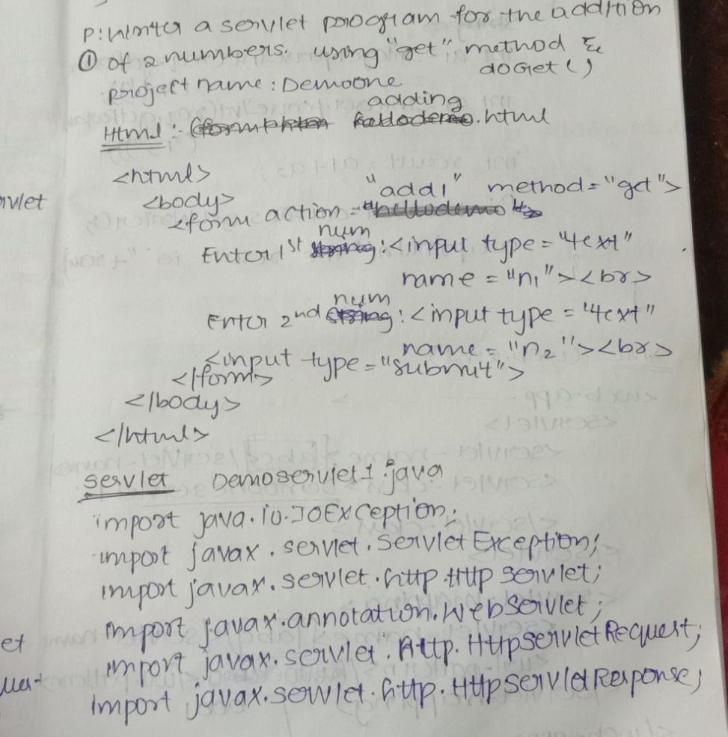

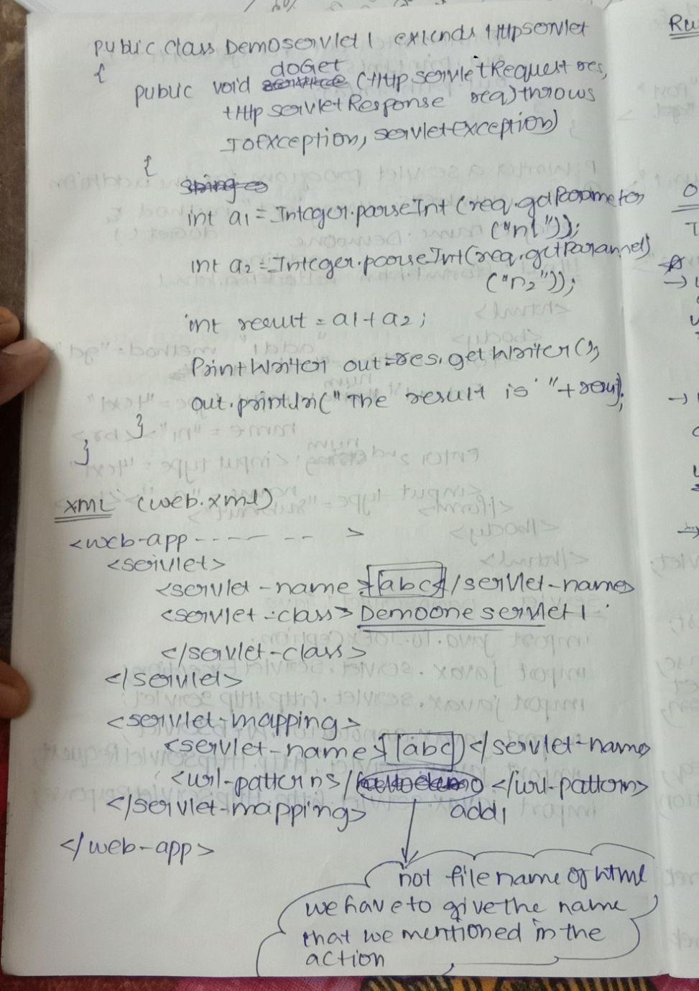

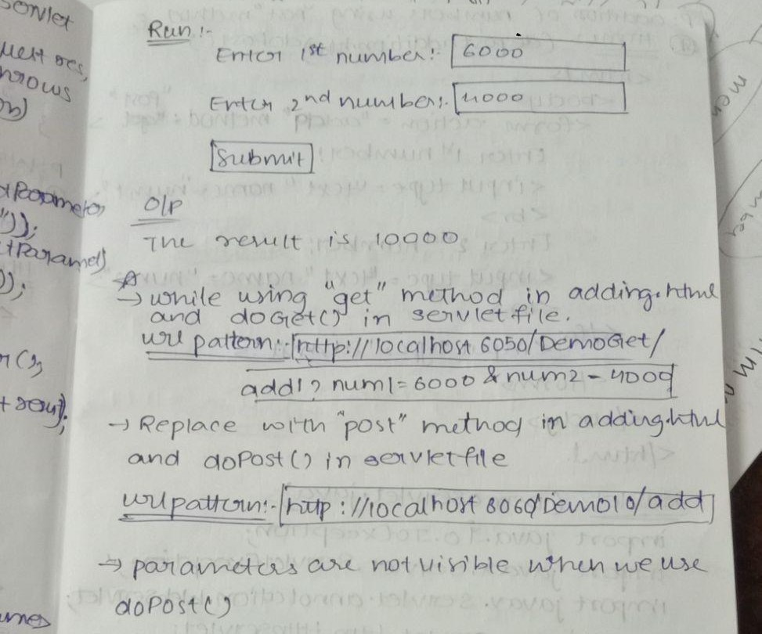

1. **POST METHOD PROGRAM**

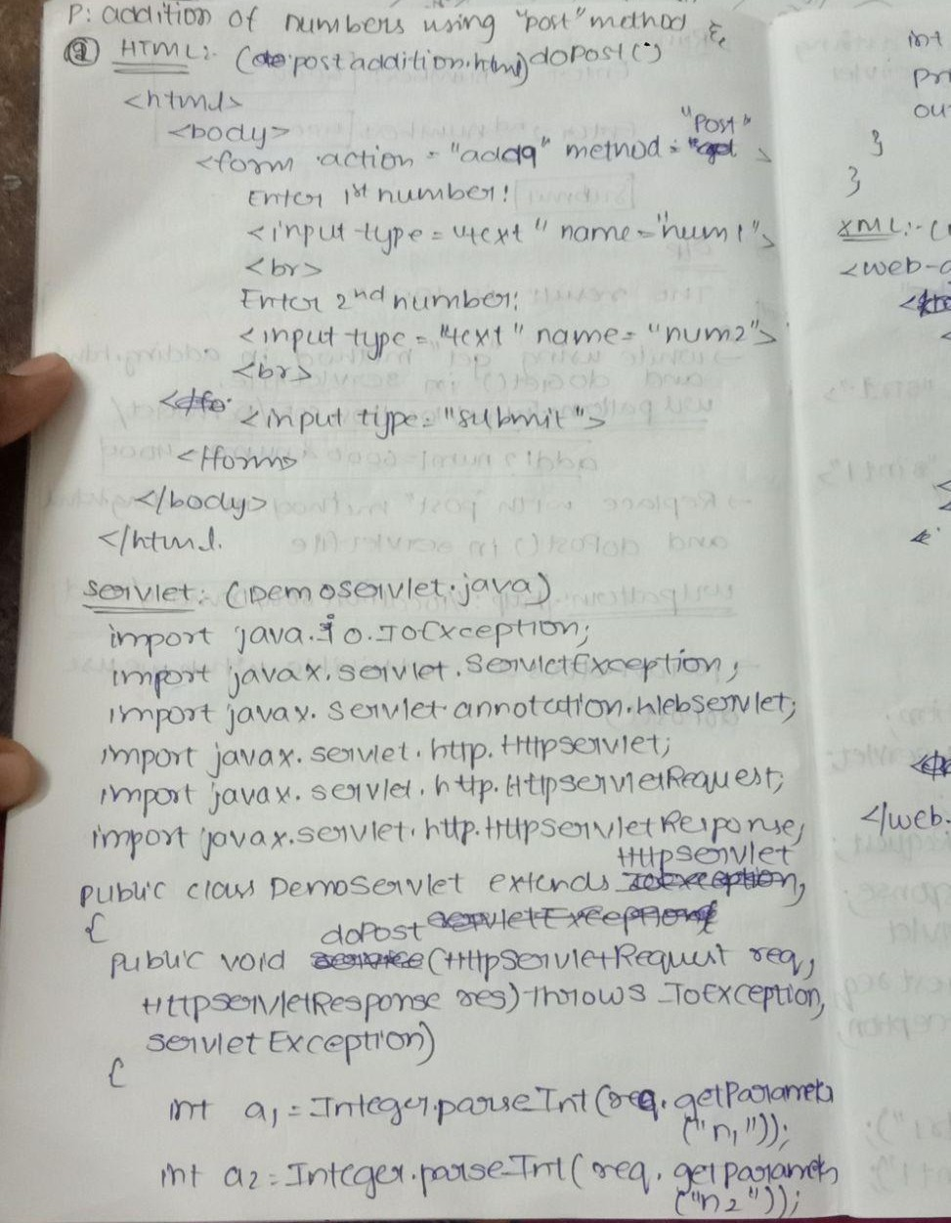

1. **SERVICE METHOD PROGRAM**

